**ORGAN DONATION APP -PROJECT**

**Project Title: “ORGAN DONATION APP” is a web app by using azure services.**

1. Project Demo URL: <https://healthorgan.z13.web.core.windows.net/>
2. Demo Video URL: <https://www.youtube.com/watch?v=t0srDtedIeg&t=2s>
3. Github Repository URL:
4. <https://github.com/Preethikasarla-55/health-project.git>
5. Industry: Organ Donation

**Azure Services Used**

1. Azure Storage Service
2. Azure Blob Service
3. Azure Containers
4. Azure static web
5. Azure Backup service

**Azure AI Services Used**

1.Language service

2.Azure Bot service

**Problem Statement**

The organ donation system faces a critical challenge marked by a severe shortage of available organs for transplantation. Despite advancements in medical technology and an increasing demand for life-saving organ transplants, the supply of donated organs has not kept pace. This shortage leads to prolonged waiting times, increased patient mortality rates, and a growing sense of despair among individuals awaiting life-saving transplants.

**Project Description**

Organ donation is a medical procedure in which an individual voluntarily donates their organs or tissues, either during their lifetime or after death, for transplantation into another person. The primary purpose of organ donation is to save lives or improve the quality of life for individuals suffering from organ failure or dysfunction. Organs and tissues that can be donated include the heart, lungs, liver, kidneys, pancreas, intestines, corneas, skin, bone, and bone marrow.

**Core Azure Services**

**Azure Blob Storage** Azure Blob Storage: Azure Blob Storage is Microsoft's scalable object storage solution in the Azure cloud. It enables secure and cost-effective storage of unstructured data, such as documents and images. Offering seamless integration with applications, it supports data of any size and optimizes accessibility through a globally distributed network. **Azure Storage Account** Azure Storage Account is a foundational component in Microsoft Azure, providing secure and scalable cloud storage. It supports various storage services like Blob, File, Queue, and Table, accommodating diverse data types. With features such as redundancy options and access controls, it ensures reliable and efficient data management. **Azure Backup Service** Azure Backup Service by Microsoft safeguards critical data in the Azure cloud. It offers automated and scalable backup solutions for virtual machines, applications, and files. With features like long-term retention and geo-redundancy, it ensures data resilience and facilitates efficient disaster recovery, enhancing overall data protection strategies. **Containers** Container services, such as those provided by Docker and managed container orchestration like Kubernetes, play a pivotal role in modern software development projects.

**Azure AI Service**

**Language service:** The service provides a range of features that enhance productivity, code quality, and collaboration. It plays a central role in creating a developer-friendly environment and facilitating efficient software development workflows.

**Azure Bot Service:** The Azure AI Language Chatbot is a cutting-edge conversational agent powered by Microsoft's Azure platform. Leveraging advanced natural language processing capabilities, it facilitates dynamic and context-aware interactions. This intelligent chatbot employs machine learning algorithms to comprehend user queries, providing personalized responses and assistance across diverse domains. Seamlessly integrating with Azure services, it ensures scalability and reliability.

**Other Azure Technologies / Services**

In the Multilingual Content Hub, Azure Monitor and Azure Application Insights collaboratively form a dynamic duo, meticulously overseeing application health and person stories.

**Azure Monitor:**

**Real-time Performance Metrics:** Monitors vital overall performance indicators, ensuring the application runs seamlessly.  
**Proactive Alert:** Issues immediately alerts on deviations from set overall performance thresholds, enabling fast responses to capability disruptions.

**Azure Application Insights:**

**User Interaction Insights:**  Analyse consumer behaviours, providing distinctive facts on trips and characteristic recognition.  
**Diagnostics Precision:** Traces requests comprehensively, facilitating quick identity and determination of issues at each frontend and backend degrees.

**Screenshots:**

**Storage Service:**

**Description:**

Storage services encompass a range of solutions designed to store, organize, and manage data efficiently. These services can vary in terms of scalability, performance, accessibility, and features, catering to diverse requirements across industries.

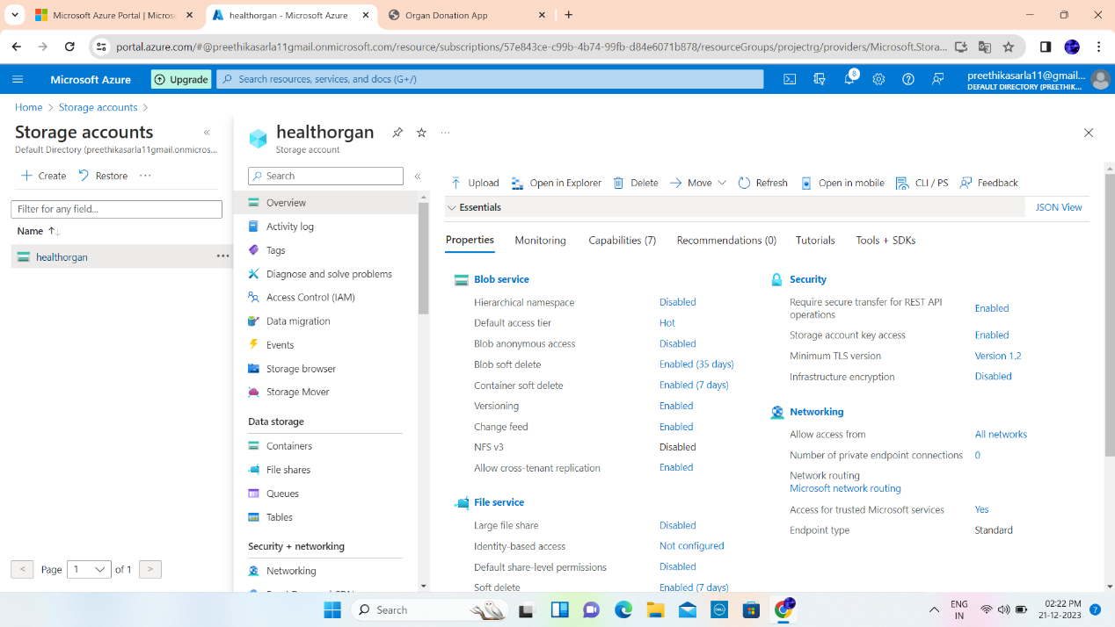

**Azure Static Website** Azure Static Website is a hosting service in Microsoft Azure designed for deploying and serving static web content. With features like global content delivery, automatic scaling, and seamless integration with Azure Storage, it provides a reliable and cost-effective solution for hosting HTML, CSS, and JavaScript-based websites with minimal configuration.

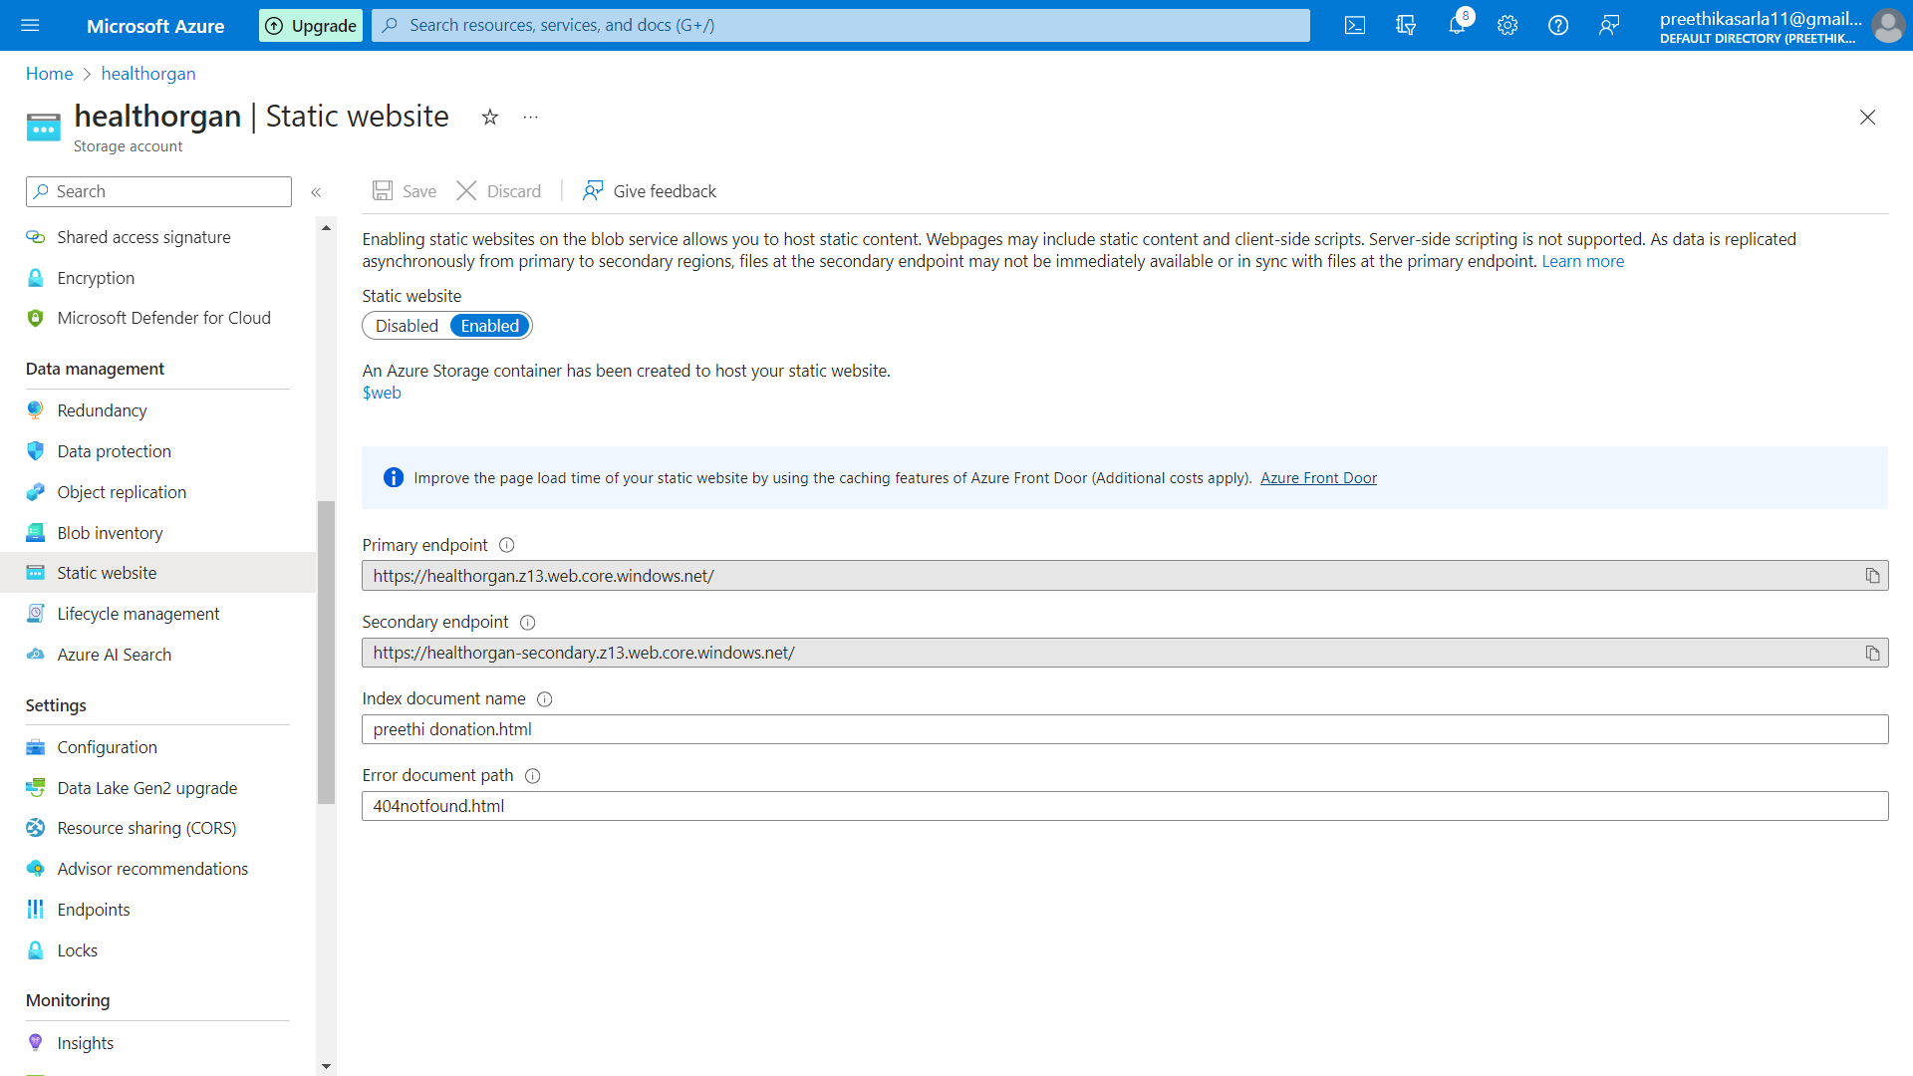

**Azure blob storage**:

**Description:**

Blob service is a cloud-based storage service designed for the scalable storage of binary or text data, often in the form of files such as images, videos, documents, and backups. It provides a simple and flexible way to store and retrieve large amounts of unstructured data in the cloud.

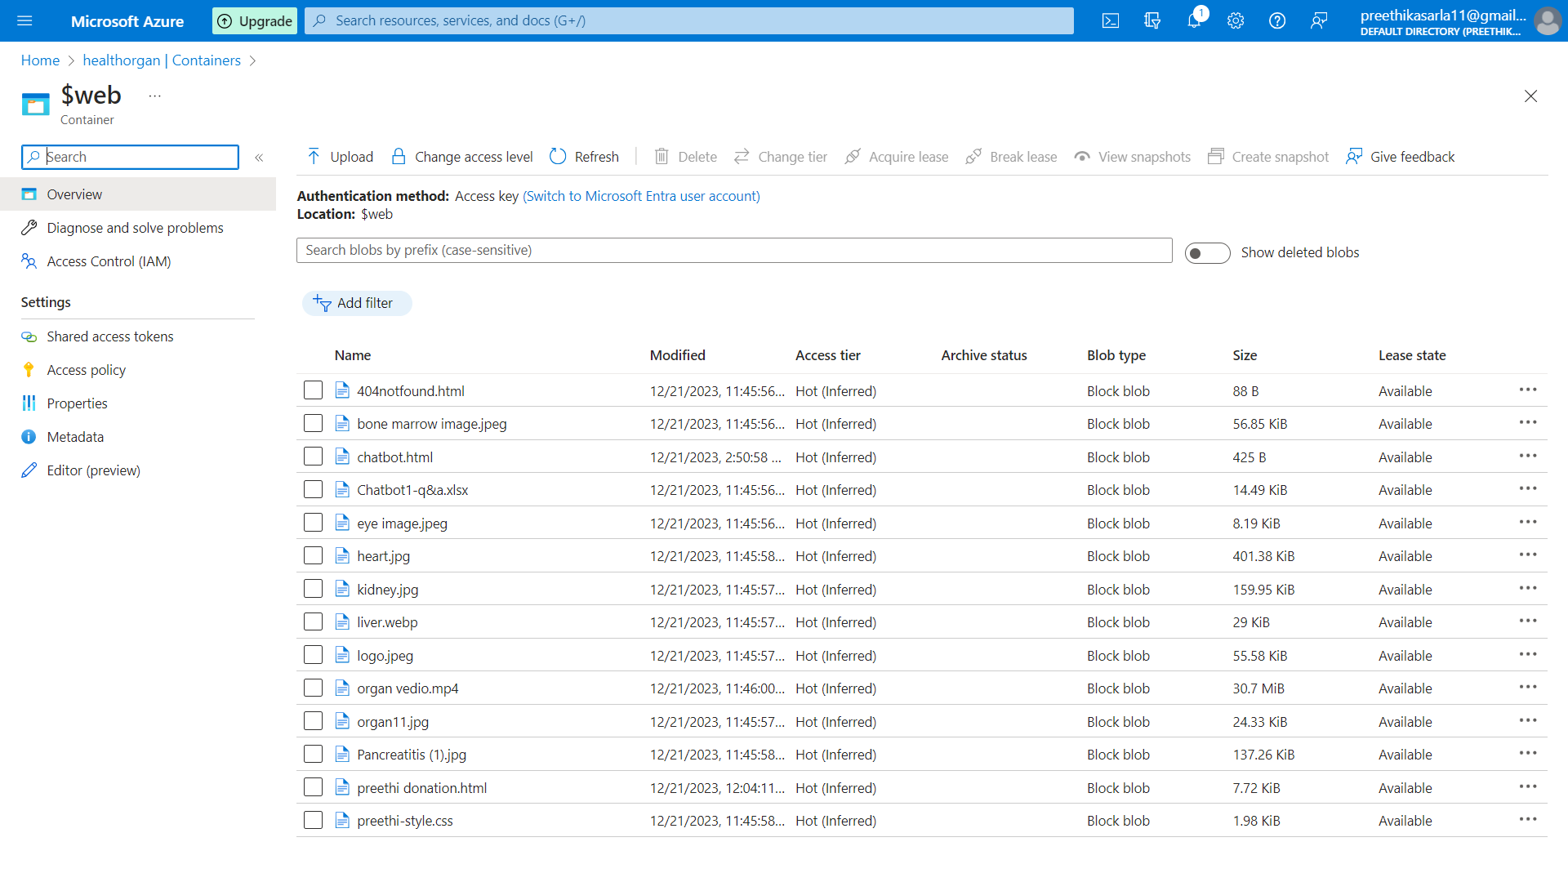

**Azure Backup Service** Azure Backup Service in Microsoft Azure ensures data resilience with automated, scalable backup solutions. Supporting virtual machines, applications, and files, it offers features like long-term retention and geo-redundancy. This service enhances overall data protection, enabling efficient disaster recovery and secure backup management in the Azure cloud environment.

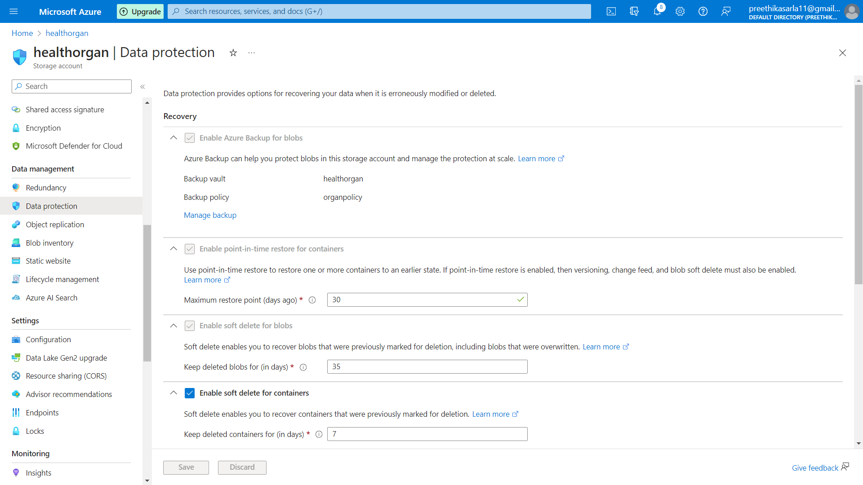

**Containers:**

**Description:**

Containers are a lightweight and portable form of virtualization that encapsulates an application and its dependencies, including libraries, runtime, and system tools, into a single, executable package. This package is called a container image. Containers provide a consistent and reproducible environment, ensuring that the application runs consistently across different computing environments, whether it be a developer's laptop, a test environment, or a production server.

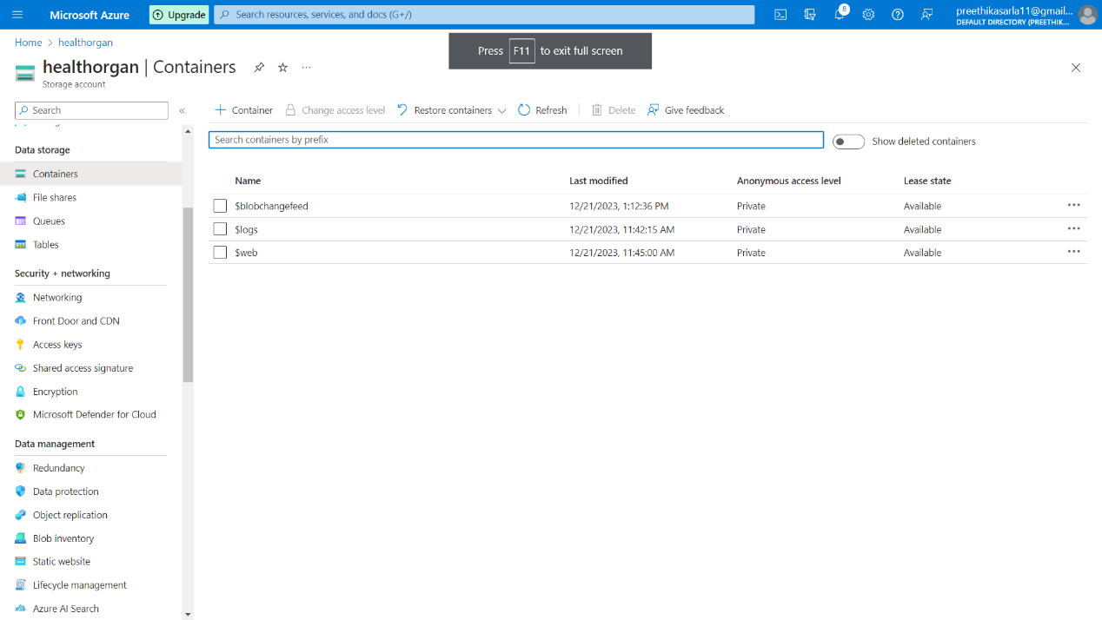

**Language service:**

**Description:**

Language service descriptions play a crucial role in providing a clear understanding of the capabilities, features, and use cases of language-related services offered by cloud platforms like Azure. It plays a pivotal role in guiding developers, architects, and decision-makers in selecting, integrating, and utilizing language-related services effectively within their applications and projects.

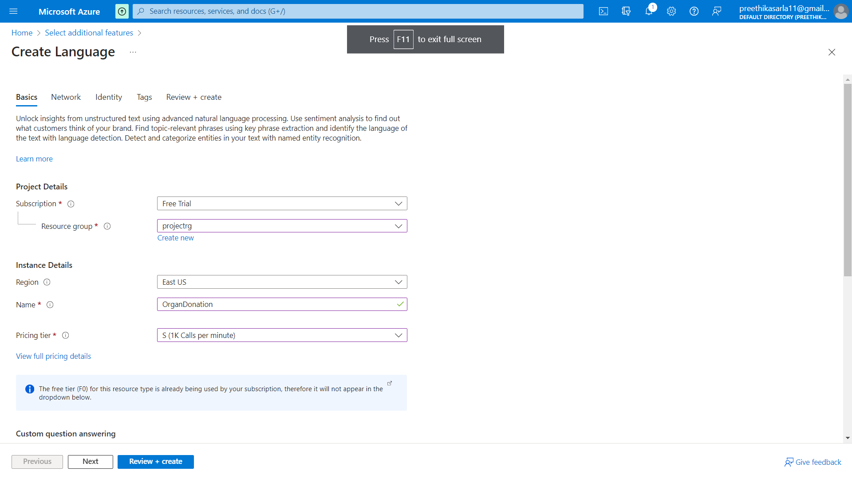

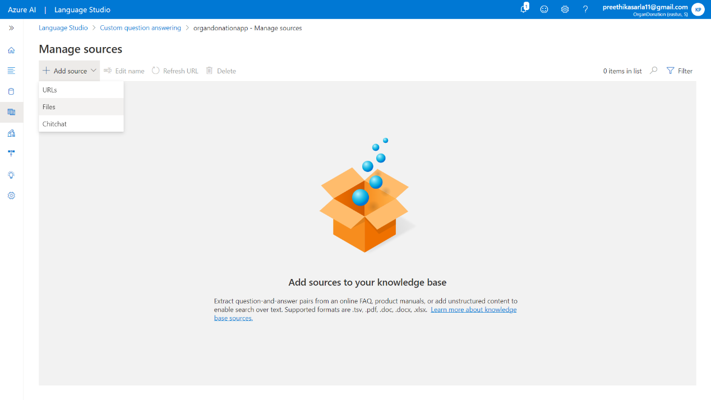

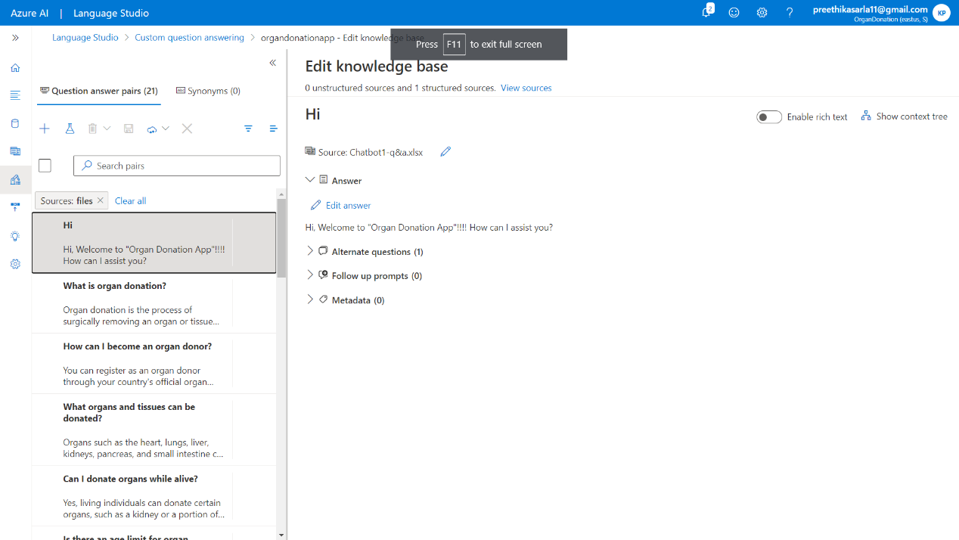

**Azure Chat Bot:** The Azure AI Language Chatbot is a cutting-edge conversational agent powered by Microsoft's Azure platform. Leveraging advanced natural language processing capabilities, it facilitates dynamic and context-aware interactions. This intelligent chatbot employs machine learning algorithms to comprehend user queries, providing personalized responses and assistance across diverse domains. Seamlessly integrating with Azure services, it ensures scalability and reliability.

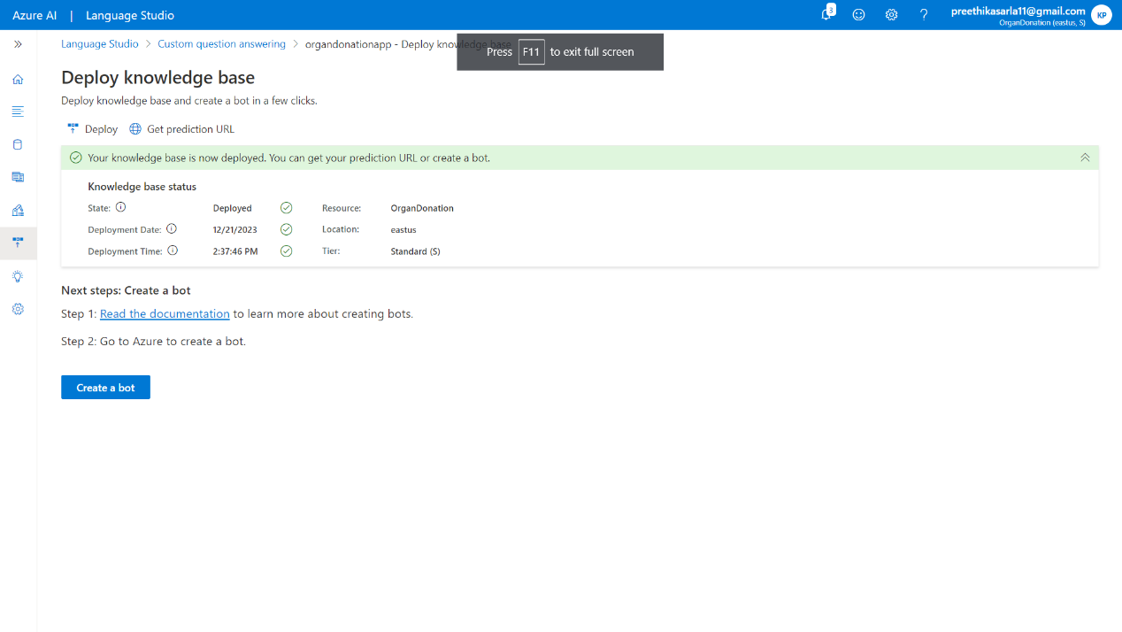

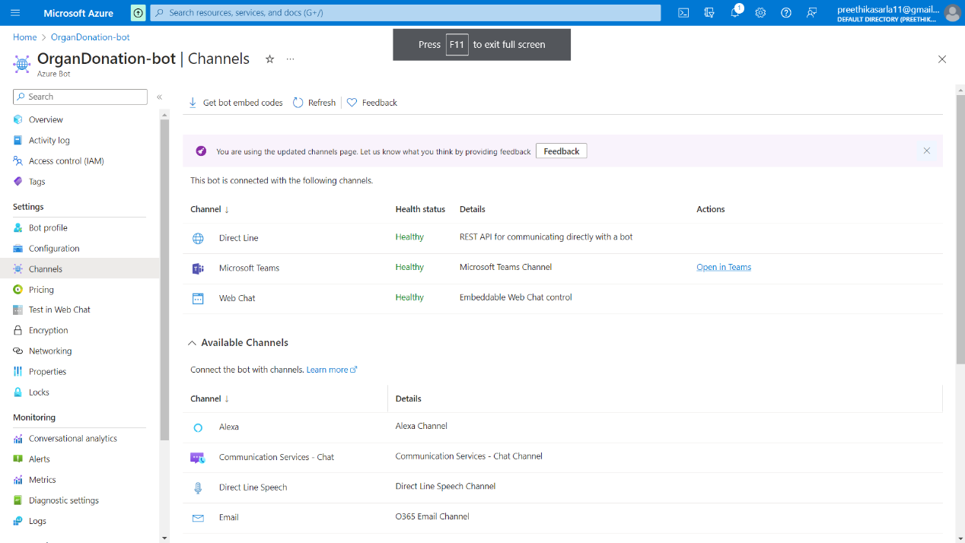

**Working Live Project Display**

**Description** Here I am attaching the final working website's screenshot for the reference.

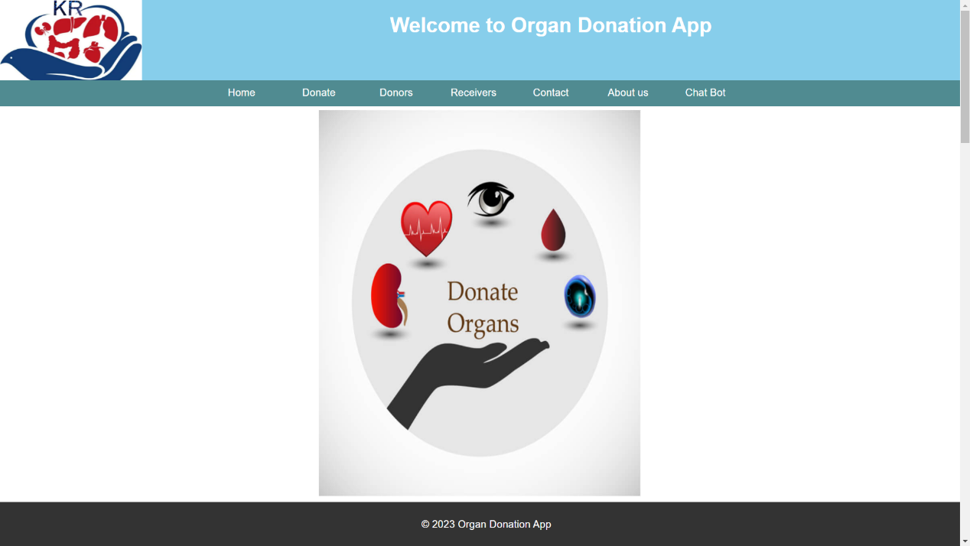

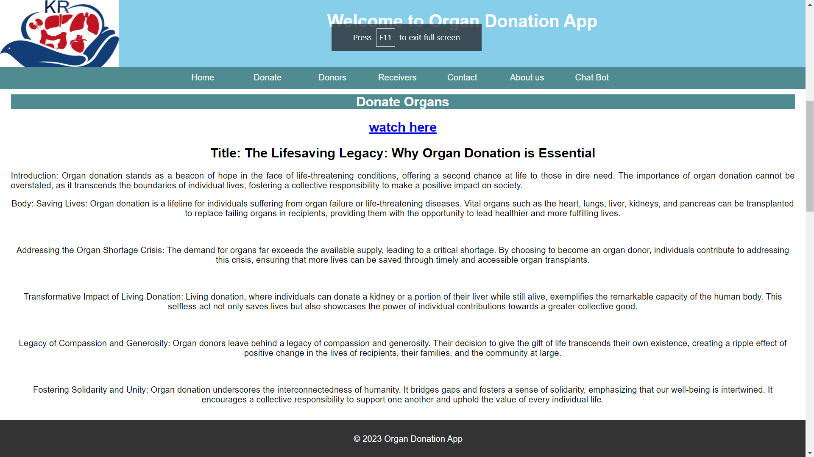

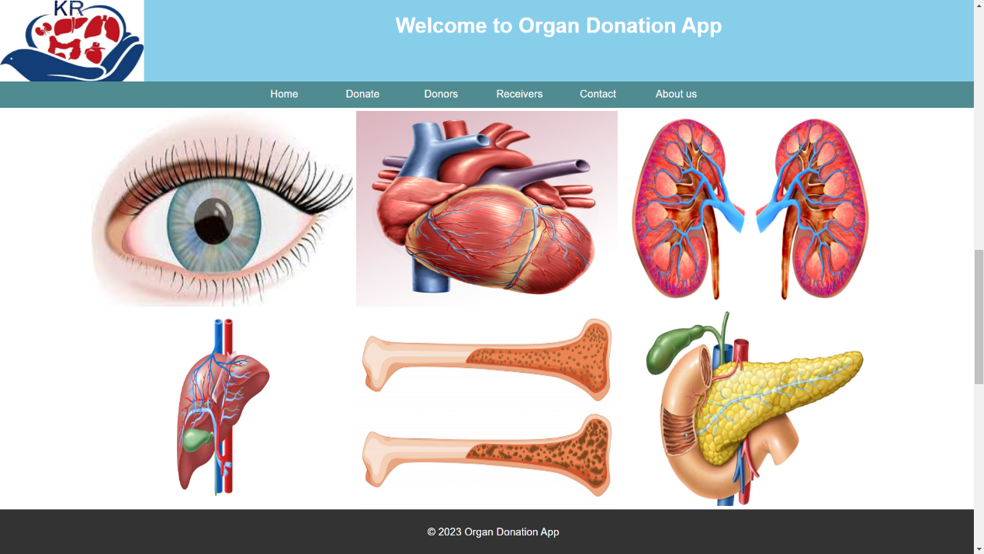

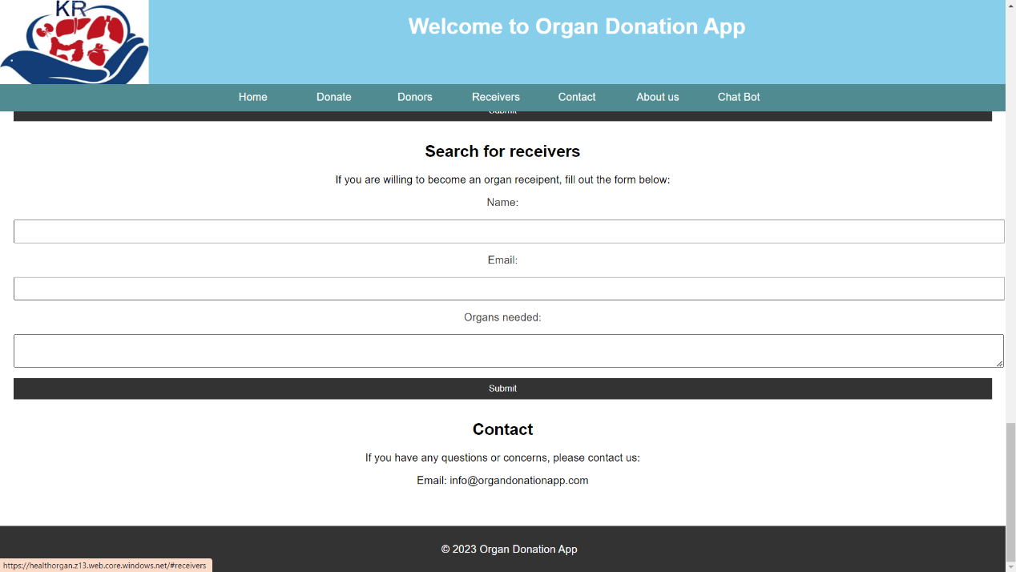

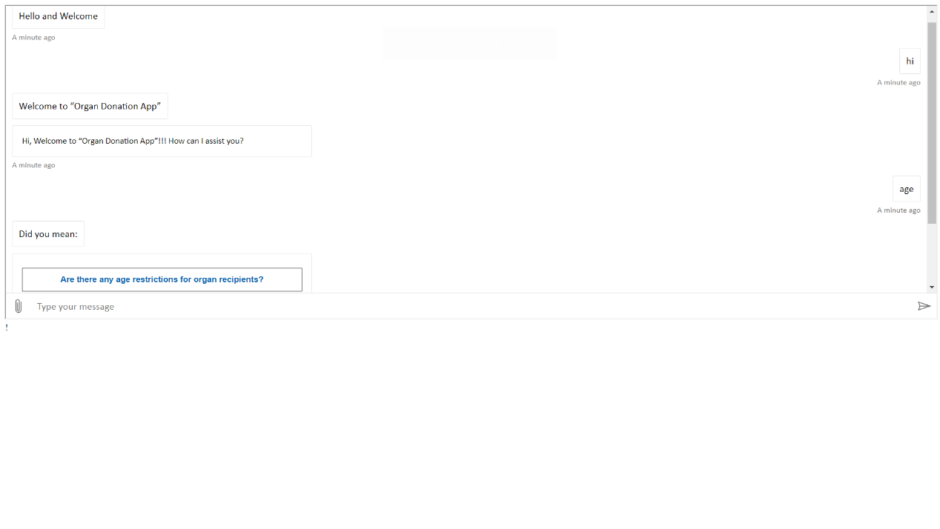

**Resource Visualizer**

[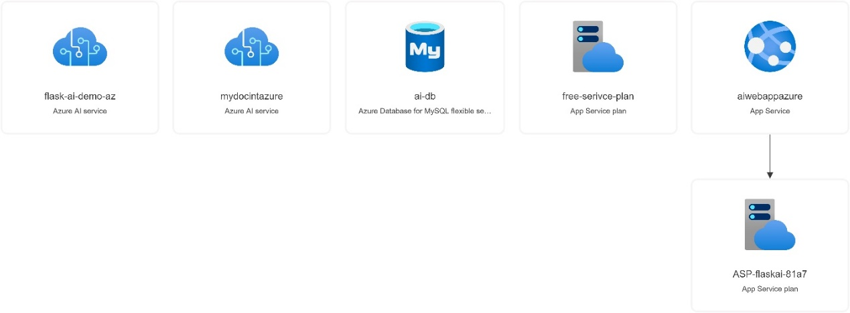](https://github.com/AnkeetaGupta/flask-ai-translation/blob/main/screenshots/flask-ai.jpg)

**Final Project Statement**

Organ donate is dedicated to promoting awareness and education about organ donation, advocating for ethical organ procurement practices, and supporting individuals and families affected by organ transplantation. Our mission is to save lives and improve the quality of life for those in need of organ transplants through education, advocacy, and community engagement.

**As we finish, we reflect on the profound impact that this initiative has on individuals, families, and communities. Throughout our journey, we have delved into the critical importance of raising awareness, dispelling myths, and advocating for ethical organ procurement practices.**

[**Organ Donation App using Azure AI Service.**](https://aiwebappazure.azurewebsites.net/)